SAGAR BHARGAVA

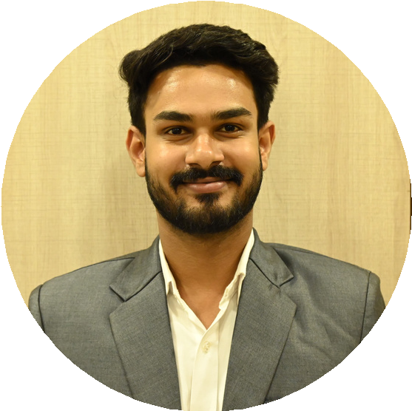

**EDUCATION**

**Master of Business Administration Krupanidhi College of Management** 2022-2024

**Bachelor of Commerce**

**S.S. Jain Subodh Commerce & Arts College, Jaipur**

2018-2021

**Class XII**

**Ryan International School**

2017-2018

**Class X**

**Ryan International School**

2015-2016

**SKILLS**

Microsoft Office

(Excel, Power point, word) Tally PRIME

Good Communication, Leadership Skills

Attention to Detail Ability to adopt situation

As an MBA candidate I’m seeking a challenging role, I aim to work with an organization that offers challenges, responsibilities, and decision-making opportunities. I’m confident that I can make a substantial contribution to a company that appreciates both excellence and creativity,

I will continue to improve and develop my skills.

# WORK EXPERIENCE

## ARTNSTONES - 2022 - Present

 Over 2 years' experience at Business ARTNSTONES, specializing in construction materials.

 Proficient in TALLY Prime for accurate accounting, including purchase, sales, and statements.

 Managed daily accounting operations, maintained records, and facilitated invoicing.

 Provided exceptional customer service, fostering strong client relationships.

 Implemented effective sales and marketing strategies to boost business growth.

 Successfully drove offline sales of ₹1.5 crore in 2023-24 and e-commerce sales of ₹35 lakhs in last 3 months, notably through platforms like Indiamart.

 Utilized Visualez to showcase real 3D tiles

 Expanded business operations to Rajasthan, Madhya Pradesh and outskirts of Bangalore, capturing new markets and increasing sales opportunities.

 Acquired basic Kannada skills during tenure, aiding communication with local clients.

## SPIDER DELIVER’S (INTERNSHIP) - APRIL 21 - OCTOBER 21

 Interned at Spider's Deliver, gaining foundational skills in GST and ITR filing, as well as basic proficiency in Tally and Excel.

 Acquired introductory knowledge of tax compliance and financial management tools, laying the groundwork for further growth and development.

# ACHIEVEMENTS

 I was involved in event management of India’s biggest Punjabi music festival called Gaana Cross blade held in Jaipur.

 Actively participated in events like cultural fests, corporate conference in college.

 Participated in Karate at district level.

# CERTIFICATION

 Financial Accounting & Analyzing  Introduction of Data Analytics

 Business Analytics  Digital Marketing

 Introduction of Risk Management